**Day 5**

**1 touch filename.sh**

**cat filename.sh**

**vim filename.sh**

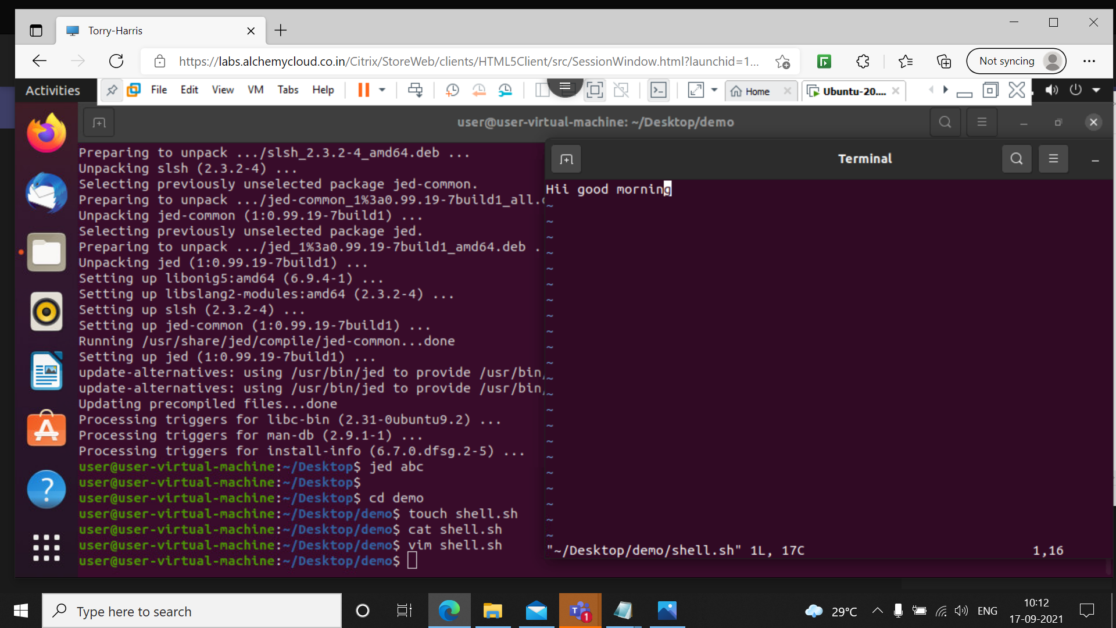Using touch command we can create a shell file by using extension .sh.

Vim command is used to edit the file in vim editor

**2 gedit filename.sh**

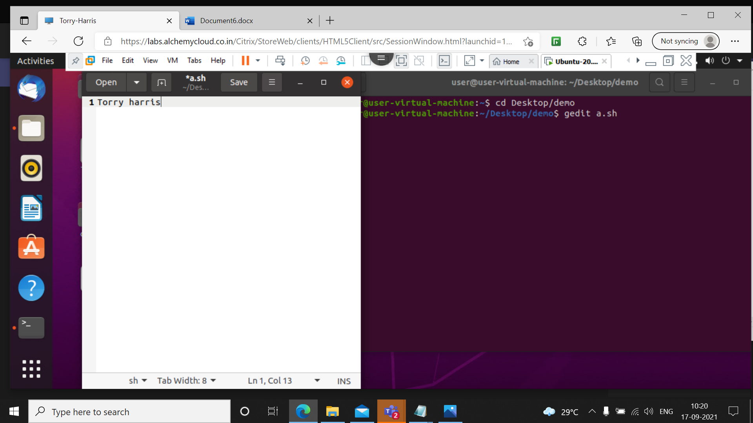

This command will open a new file

**3 ./filename.sh**

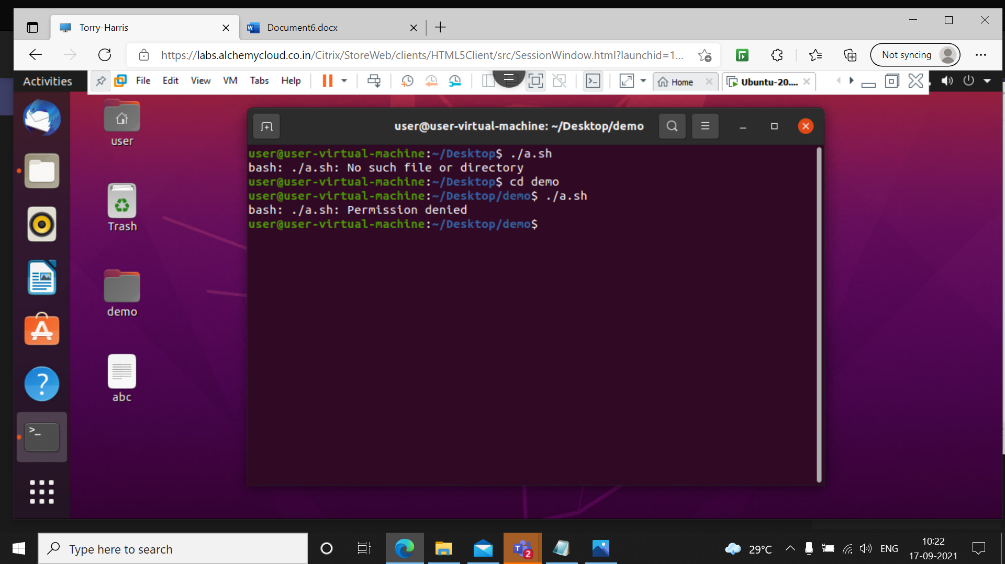

This command is used to execute the shell file

**4 chmod u+rx filename.sh**

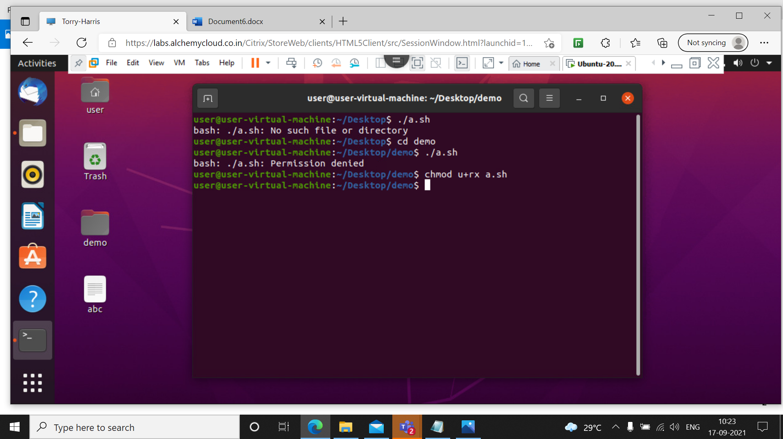

This command is used to give read & execute permission to the user of the bash shell file

**5 ./filename.sh**

**6 ./chmod 777 filename.sh**

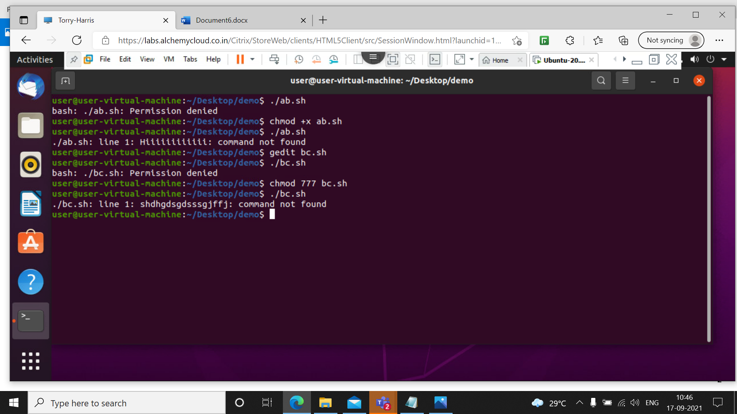

It gives all permissions to the shell file

**7 chmod 000 aa.sh**

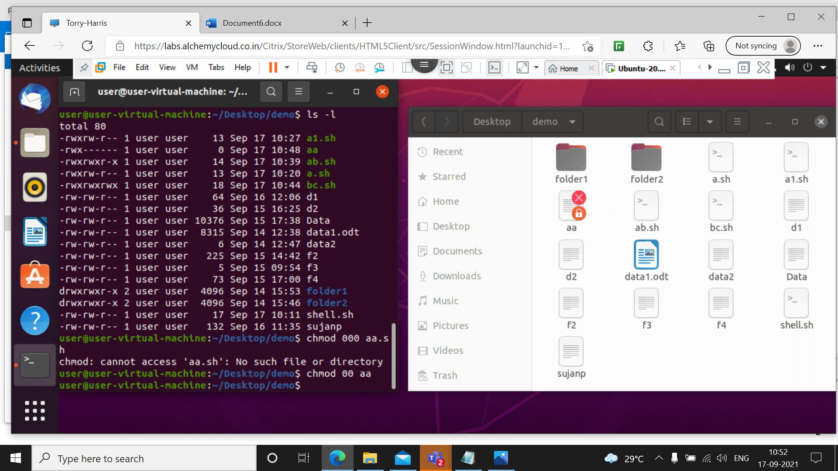

This command will block the permissions of file

**8 chmod 444 aa**

**Ls -l**

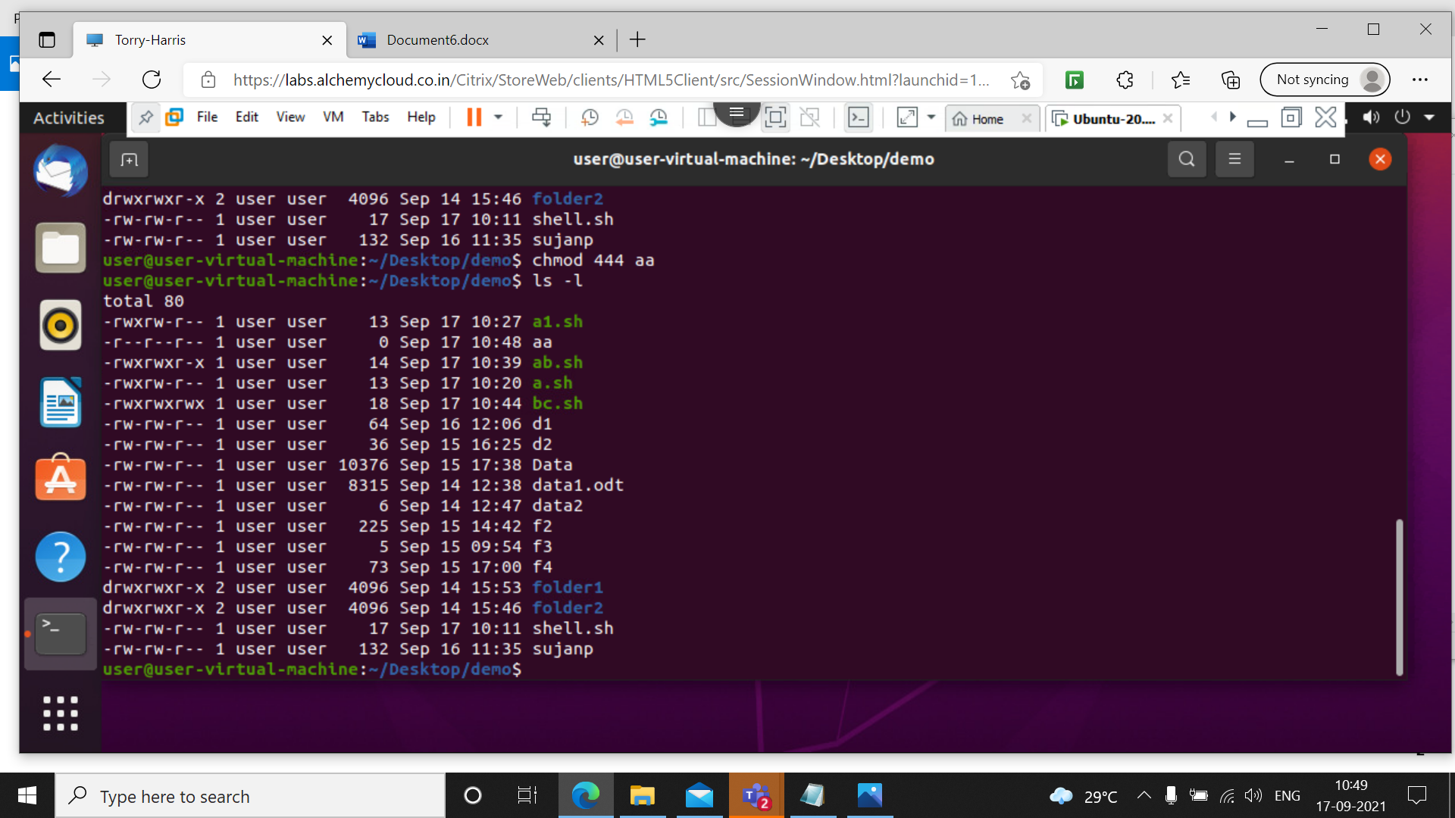

This command will give read permission to the all users

**9 chmod 700 aa.sh**

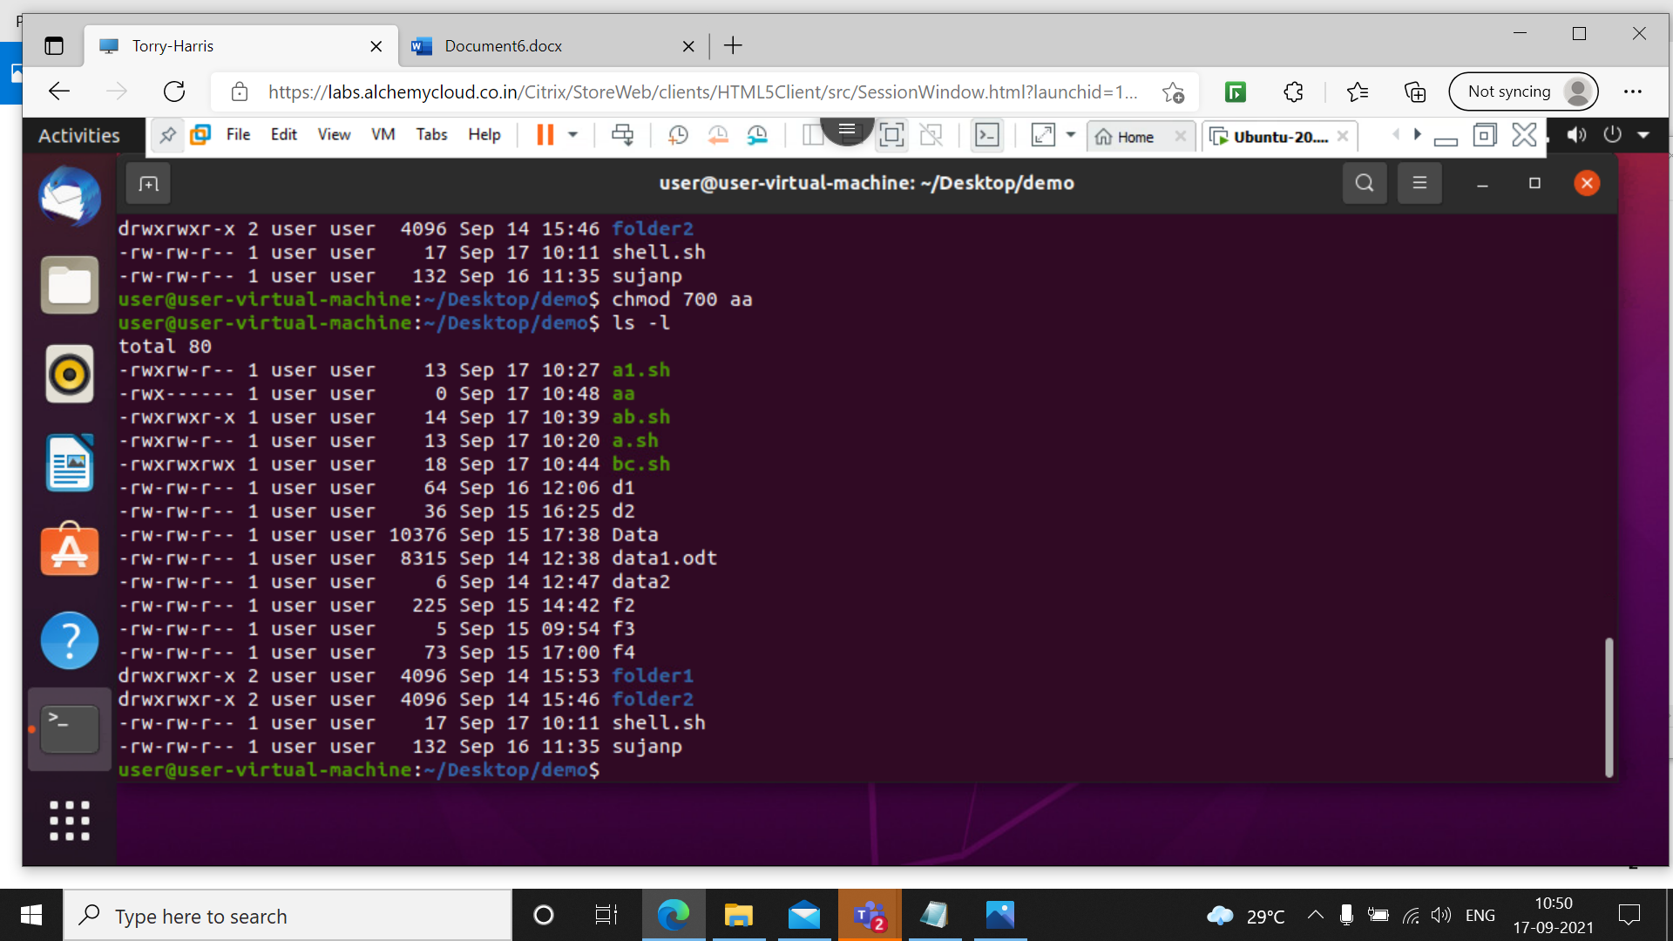

This command will give all permissions to the user only

**10 ./filename.sh**

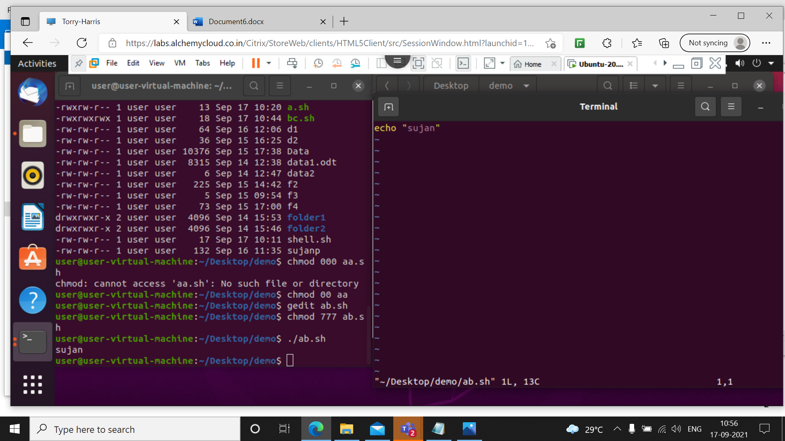

This command will prints data from theshell file

**11 chmod 777 filename.sh**

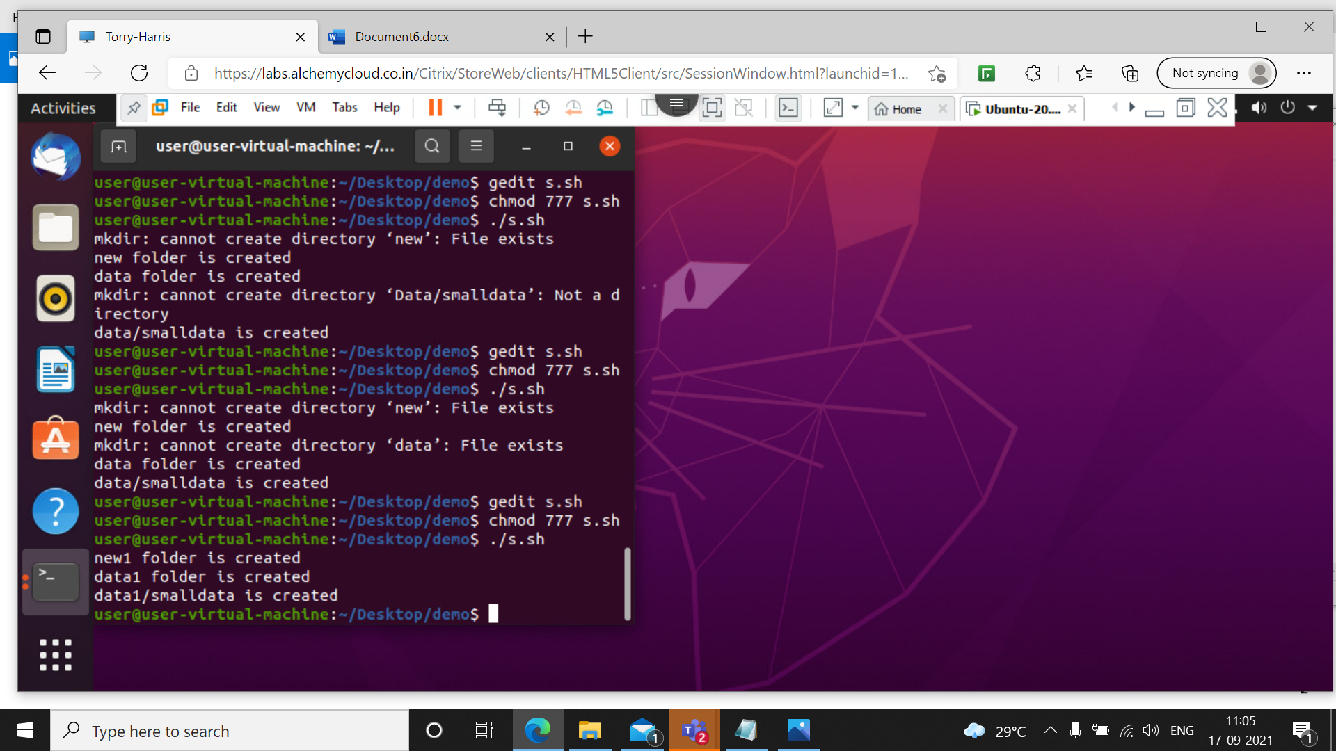This command will provide read, write and execute permissions and create multiple folders in shell

**12 rm –rf folder1**

**rm –rf folder2**

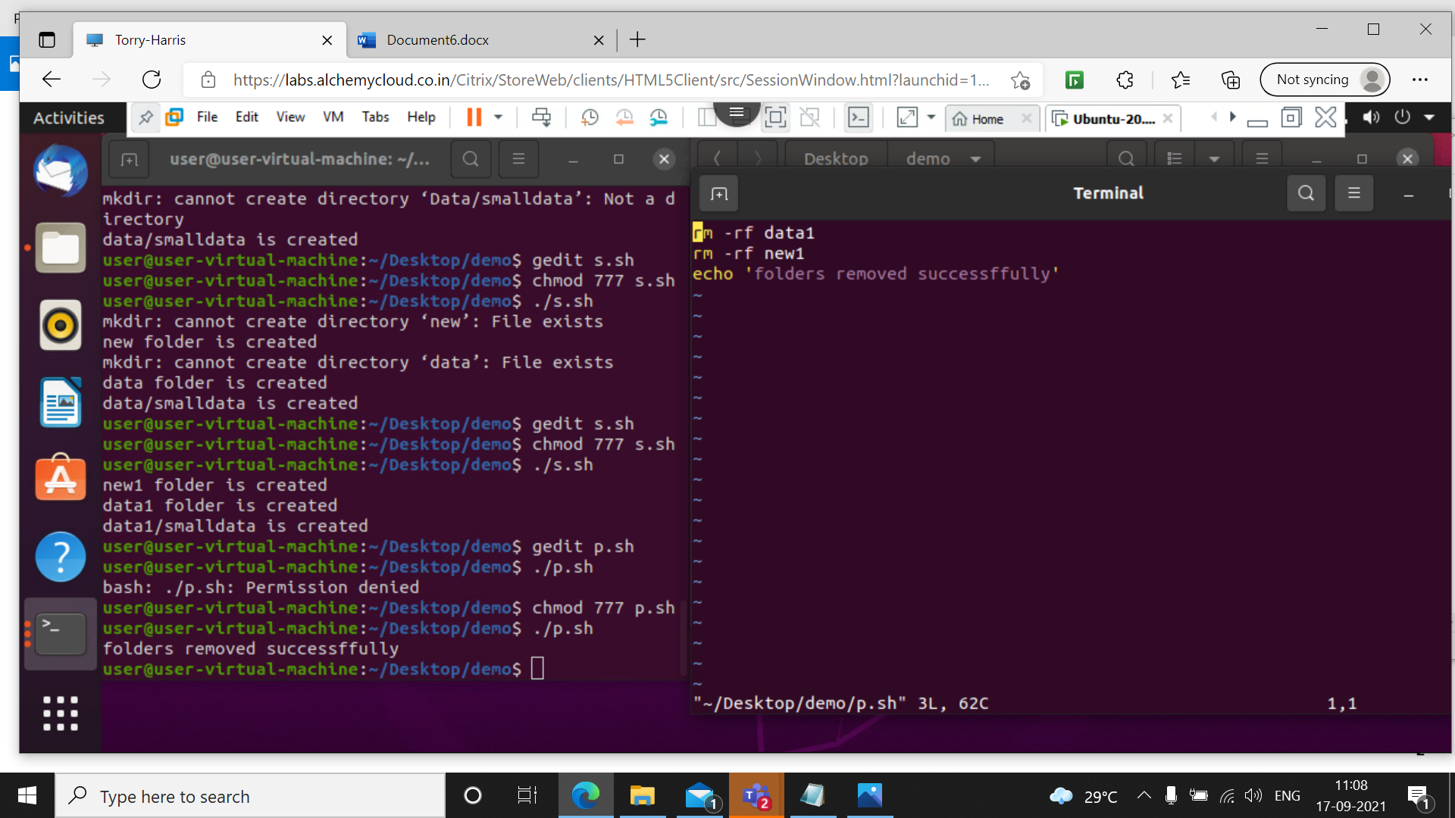This command will remove the files in the shell

**13 ./filename1.sh > filename2.txt**

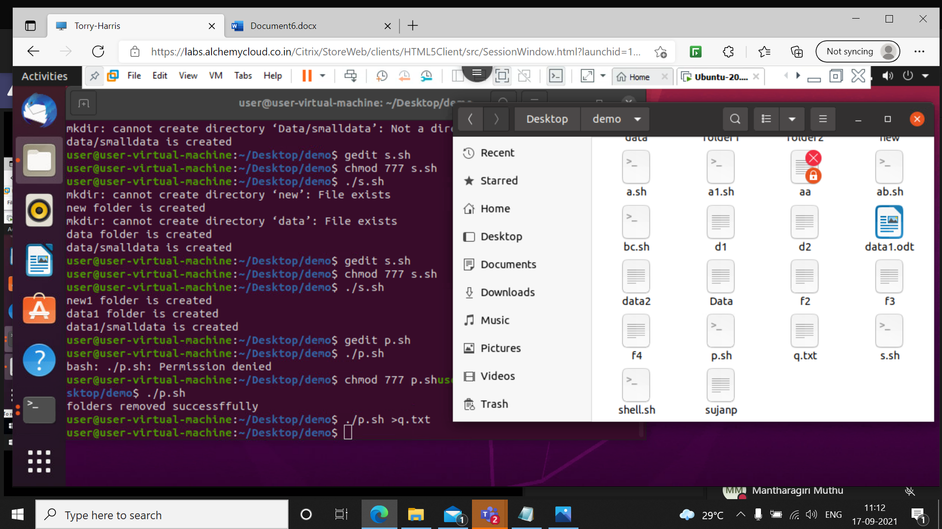

This command will paste the data from one file to another

**14 echo ‘line 1’ >>log.txt**

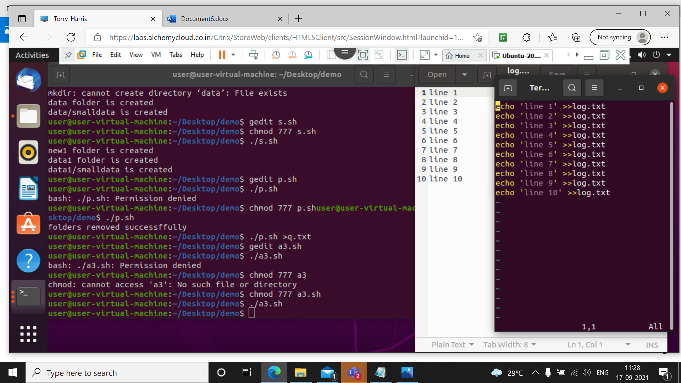

This command is used to store multiple line into text file

**15 Program to find the diagonal of rectangle**

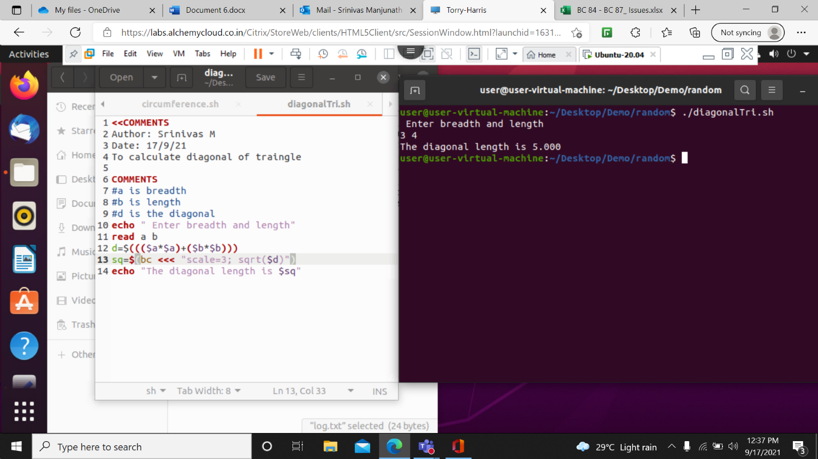

**16 Program to find the circumference of circle**

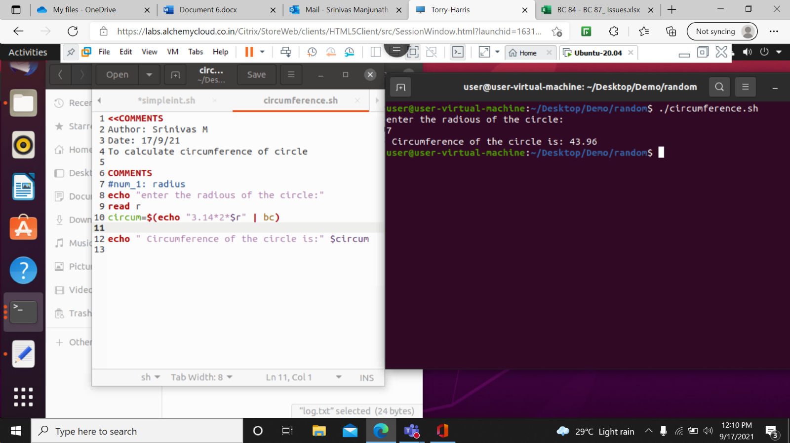

**17 Program to find the simple interest** 